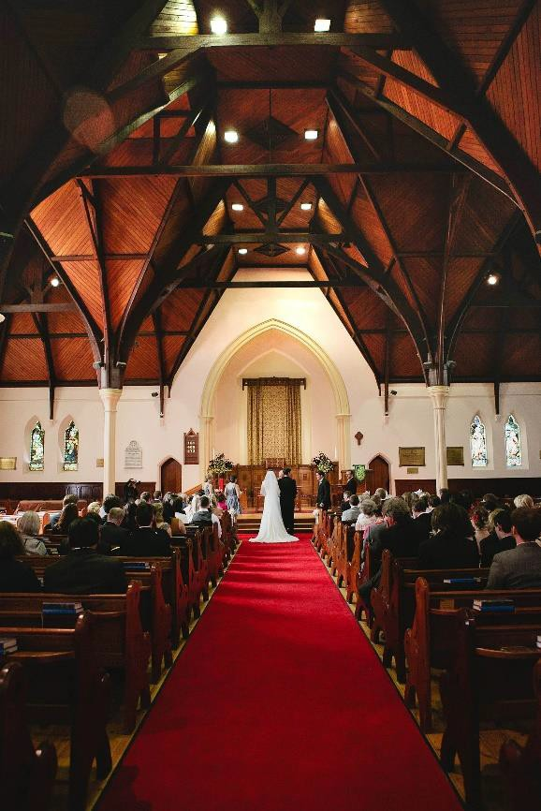
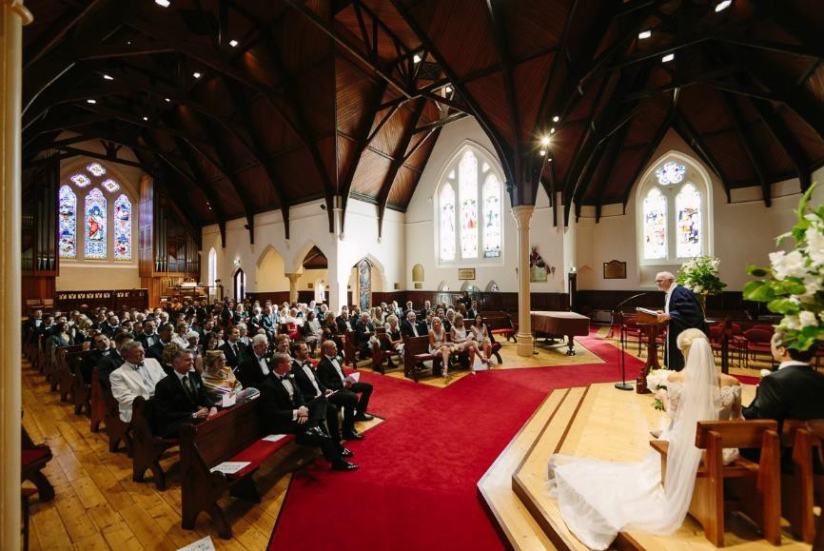

FAQs about Weddings

General:
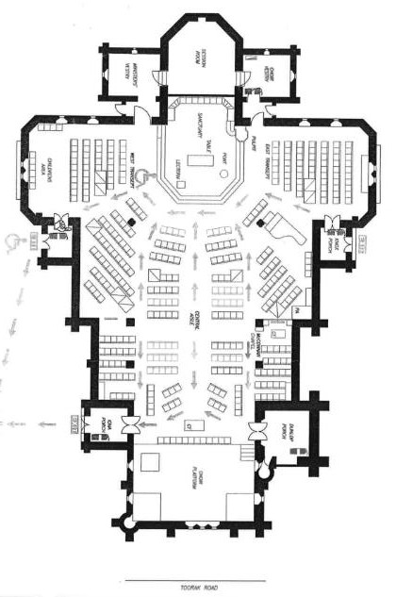
- What is the cost of a wedding at TUC?
  - Wedding packages start at $3,000
  - Your wedding is confirmed upon payment of the $750 non-refundable deposit
- I don’t think we need the organist / Church Officer / other. Will the wedding cost less without them?
  - No. The packages start at $3,000. Should you choose not to use some of the inclusions, the price will not be lowered.
- How many people does the church hold?
  - 350 comfortably (400 at a pinch, some seats with obscured views).
- How many pews are there?
  - 15 rows (5-seat pews) either side of aisle,
  - 12 rows (3/4-seat pews) either side of that,
  - 50 people in each transept (various 3-12-seat pews)
- How long is the centre aisle?
  - Approx.16m

- NO FOOD OR DRINKS may be brought into the Church. (Bottled water for the wedding party is acceptable.)

- Can I hire a room for post-wedding refreshments?
- Yes – for room hire, refer here: http://www.toorakuc.org.au/weddings-facilities/facility-hire/

Flowers and decorations:
- Can I decorate the pew ends?
  - Yes, but the decorations must be removed by you at the end of the service. The top of the pew is 20cm wide and 4.5cm thick.

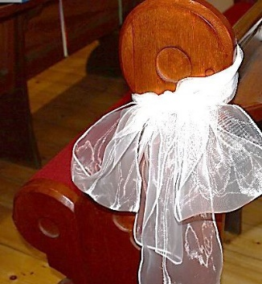
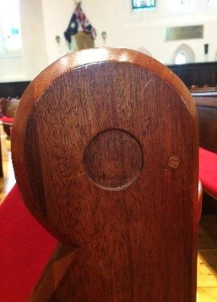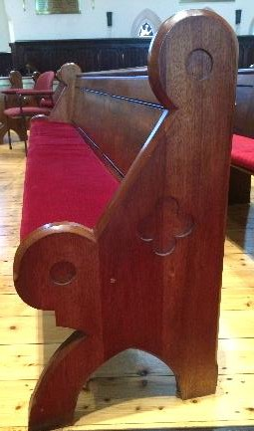

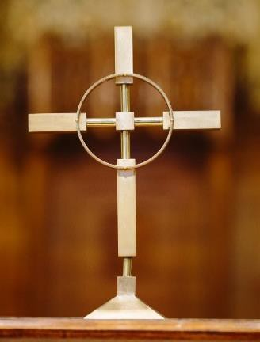
- Do you have a cross?
  - Yes, we have a brass cross for the altar table and a wooden cross on the wall above the pulpit. The brass cross is 33cm tall.
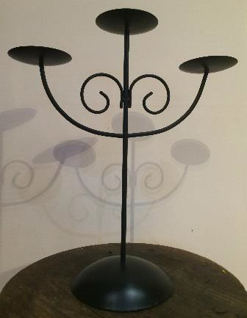
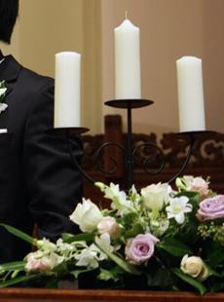
- Do you have a candelabra?
  - Yes, we have a 3-arm candelabra which is 42cm tall
  - We also have a pair of semi-circular, 7-arm candelabra that are about 150cm tall.
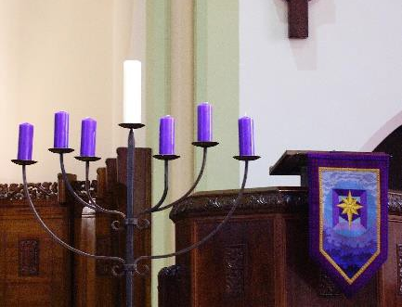
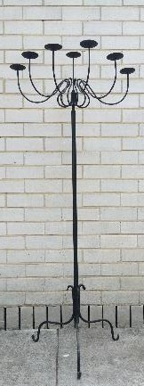
  - You are also welcome to bring your own candelabra.
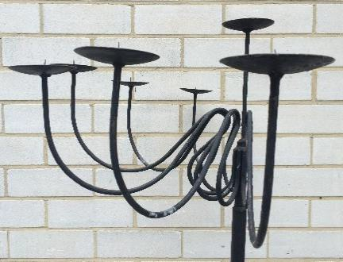

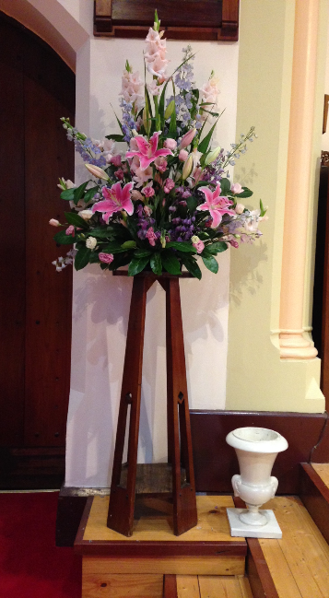
- How many flower arrangements should we have?
  - As many or as few as you’d like!
  - We have two matching 1m wooden pedestals for the front of the church, and a third one that is very similar.
  - You can put flowers on the altar table and/or on the table at the rear of the church if you wish to.
  - Your florist will generally supply the vases and bring the flowers into the church either the day before or the morning of your wedding.
- Can I take the flowers home / to the reception?
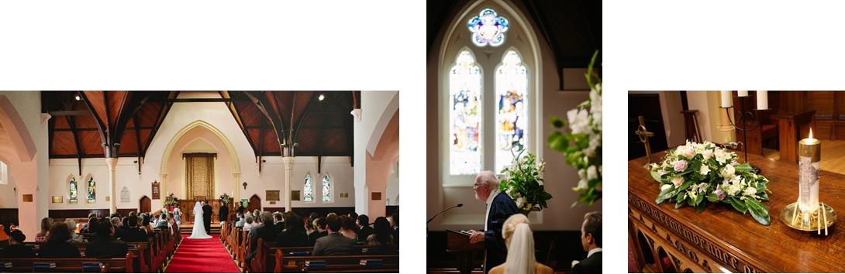
  - Absolutely, but the congregation will happily enjoy them if you would like to donate them – just let the Office Managers know what you plan to do.

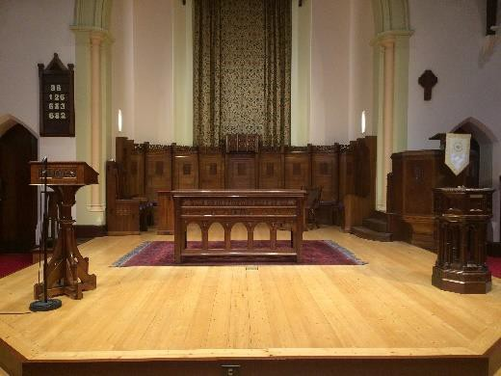
Music:
- Can we move the piano?
  - No.
- Can my friend play the piano?
  - Please call our Music Director, Dylan Quinlan-Baskett, with music enquiries: 0490 371 924.
- May we play recorded music rather than (or as well as) have live music?
  - Yes – no worries.
- Can we have other musicians as well as the pianist / organist – like a string quartet?
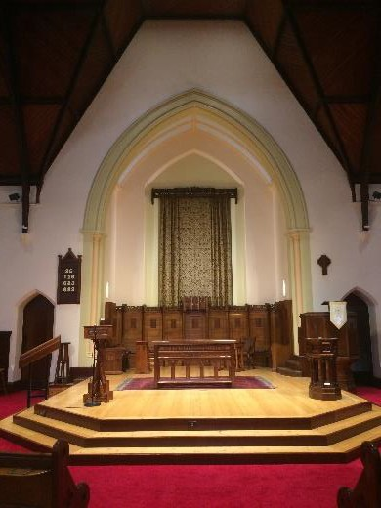
  - Yes. Please discuss this with the Minister and Music Director.
- Can we amplify our musicians?
  - Plenty of notice is needed if you want to amplify your musicians. TUC is not a specialist live performance venue, so we may not have the necessary plugs or cords to attach guitars or other instruments to our PA. We strongly suggest that your musicians provide their own portable PA. If not, they will need to make an appointment to come in and see if it is possible to amplify them in the way they require. We have one amplification point in front of the Communion table, and another in front of the Pulpit. These are not close together, and they are set up to amplify spoken word rather than musical instruments.

Videos:
- Can our videographer plug into your audio system?
  - No. Your videographer must bring their own equipment.

Furniture:
- Can we move the altar table / font / lectern?
  - Only with the express permission of the TUC minister.

Christmas:
- Can we move the Christmas decorations?
  - No, sorry. This is a working Christian church with an active worshipping congregation.
  - The Christmas tree can be moved slightly in consultation with the Minister, but the large blue banners may not be moved.

